WOMEN
AGAINST WAR


Join other women to work for peace!

NO WAR ON IRAN
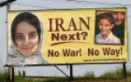
Billboard… Petitioning… Lobbying…

GRANNIES FOR PEACE

Vigils… supporting vets’ services…
countering military recruitment…

IRAQI REFUGEES
Education… lobbying…
bringing Iraqi refugee students here…
JOIN US!
www.womenagainstwar.org info@womenagainstwar.org
 518-426-0710

